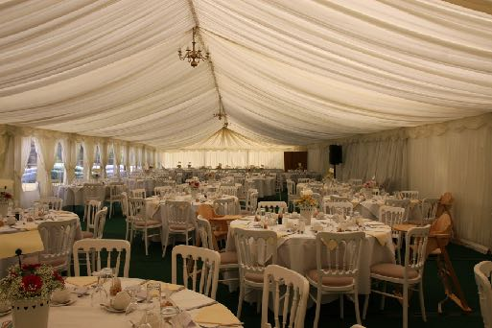
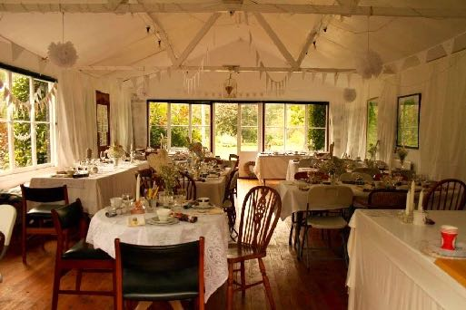
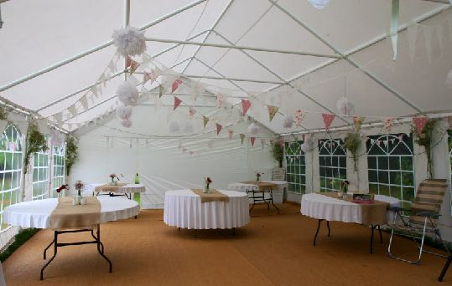
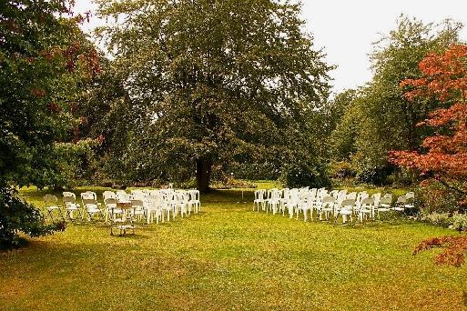

Green Island Gardens

Private Functions &

Weddings

Park Road

Ardleigh, Colchester

Essex, CO7 7SP

www.greenislandgardens.co.uk

info@greenislandgardens.co.uk

01206 230455
GREEN ISLAND GARDEN WEDDINGS
Why choose Green Island Gardens for your wedding?
Green Island Gardens is a blank canvas, ready to be painted to fit your special day. We pride ourselves on offering a venue that is adaptable to each couples individual requirements. You have access to our beautiful 20 acre grounds, perfect for enchanting photos and occupying your guests, with exclusive access to the grounds from 5pm.
Are you licensed for weddings?
Due to current legislation we are unable to hold a traditional wedding, but we are able to offer alternative weddings. We have had many couples choose to perform the legal part of a traditional wedding in a registry earlier, allowing for a beautiful ceremony in our garden.

GREEN ISLAND GARDEN FUNCTIONS
Where is Green Island Gardens?
Green Island Gardens is outside the village of Ardleigh, east of Colchester.
Rooms Available
Green Island Gardens has two options for room hire. The tearoom or outdoor marquee, each room accommodates up to 60 people; hire fee includes rectangular tables, chairs and electricity. Decorations are up to the individuals, they can be placed inside or outside, flowers can be arranged if requested.
Disabled Access
The grounds are mostly flat only one or two slight inclines and steps. For ease of entry into buildings we have ramps, a dedicated disabled toilet and wheelchair that is available for use.
Catering
Catering suppliers can be brought in at no additional costs; crockery and cutlery are available to hire. Alternatively, Green Island Gardens can cater your event, pricing varies, dependent on requirements. Contact us for more details.
Photographs
Photos can be taken at Green Island Garden, provided that the photographs are not for commercial purposes. We do ask that if any images are uploaded to the internet that you credit them to Green Island Gardens.
Confetti
Any confetti used must be biodegradable. Please no rice.
Music/PA
All amplified noise must cease by 11.30pm, guests must vacate the premises by 12 midnight.
Toilets
Toilet facilities are available for smaller functions, larger groups will be required to hire a generator and toilet block.
Alcohol license
Green Island Garden does not hold a liquor license and cannot sell alcohol. You are welcome to bring in your own, or hire a bar, there is no corkage charge. We are permitted to serve meals with a glass of wine included.
Groups over 50 people
For larger groups a marquee can be hired and placed either in the main gardens or on the large grassed car park.
Price
Outdoor marquee £300.00 + £9.00/adult
Grounds hire for weddings £2500.00
A £200 security deposit is required and will be held against damages, this money is only refundable after the event has taken place. We regret no refunds on cancellations.
GREEN ISLAND GARDENS WEDDING/FUNCTIONS BOOKING FORM

Name:

Address:

Telephone:

Email address:

Date & Time:

Number of people:

Catering required:

Staffing required:

Name/tel of marquee firm: if applicable

Venue: Marquee: Security Deposit: £200

Total to be paid

Please tick to acknowledge

☐Security deposit will be held against damages, refundable after event. No refund on cancellations

☐All damages and breakages must be paid for in full.

☐Visitors are asked to take care when visiting the gardens. Decking and stepping-stones may be slippery, as may the steps to the tree house. The owners cannot be held responsible for any accidents that may occur during the visit. Parents are asked to keep children off the trampoline, climbing frame and swings, as we cannot be held responsible for any accidents. Cars are parked at the owners risk.
Signature

Please return this form and deposit as confirmation of booking to:
Green Island Gardens,
Park Road, Ardleigh,
CO7 7SP
Green Island Gardens
Park Road
Ardleigh
Colchester
CO7 7SP

Date__________________________

Disclaimer for private functions at Green Island Gardens, for
trampolines, swings and children’s play equipment.

I _______________________________________ understand that I am responsible for my guests if they use the trampolines and children’s play equipment, and that if any accidents should occur the owners of the gardens are in no way responsible.

Signed ____________________________

