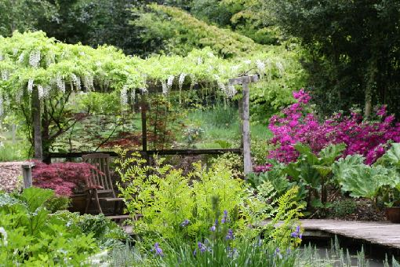
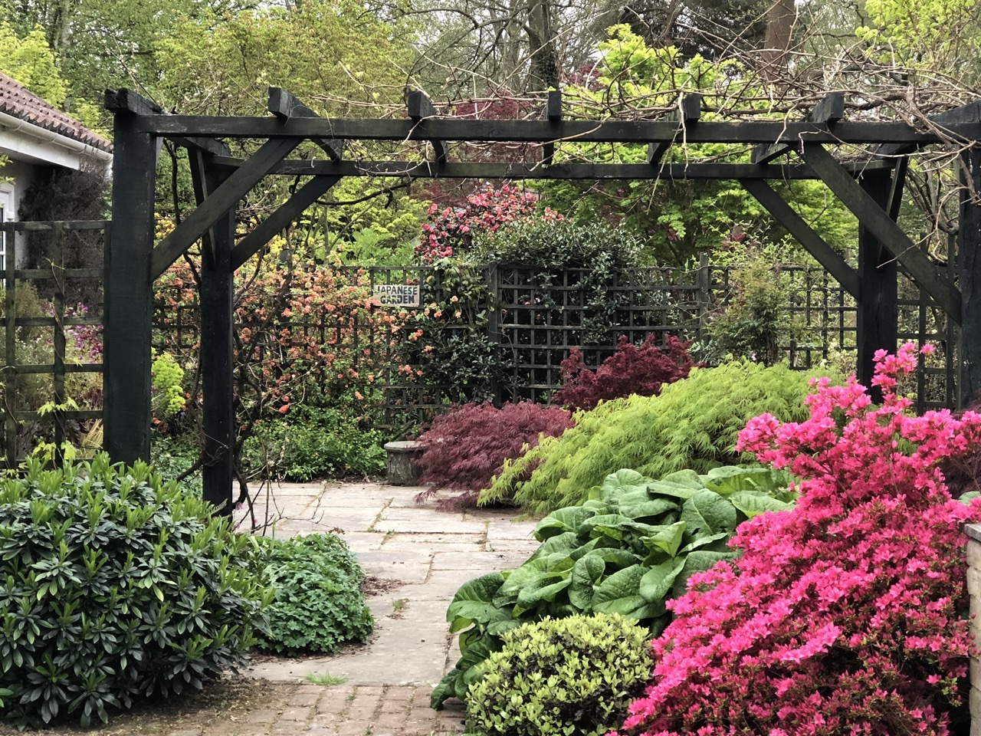
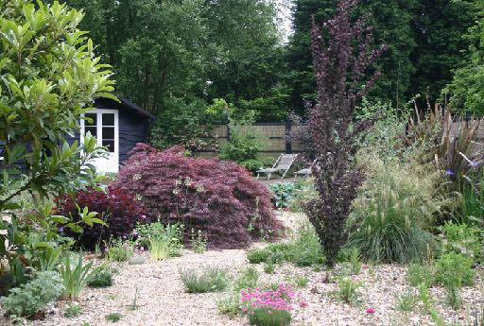
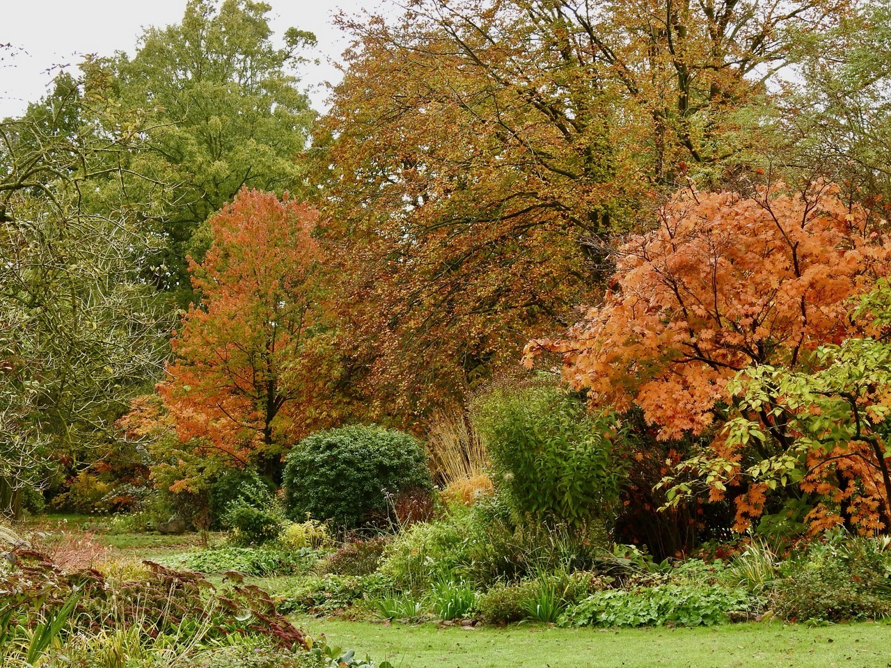

Green Island Gardens

Group Bookings

Information Pack

Park Road

Ardleigh, Colchester

Essex, CO7 7SP

www.greenislandgardens.co.uk

info@greenislandgardens.co.uk

01206 230455
GREEN ISLAND GARDEN GROUP VISIT FAQ

Why visit Green Island Gardens?
Green Island Garden is a 20-acre garden in Ardleigh, near Colchester, featuring many unusual plants, designed for year-round interest. Due to the unique micro-climate Green Island enjoys, we can grow many plants of borderline hardiness. The woodland provides shelter, so the temperatures is often up to 5ºC warmer in summer and 5ºC cooler in winter - so the snow lasts just that little bit longer. The gardens have been professionally designed by Fiona Edmond, MA Cantab Dip Hons ISGD, with a passion for trees and shrubs, plants for scent and rarely seen plants.
When is Green Island Gardens open?
January, November and December: 10.00 to 16.00 Tuesday to Saturday
February, March & April- October: 10.00 to 17.00 (or dusk) Tuesday to Saturday and
11.00 to 16.00 Sundays and Bank Holidays
Day & Evening visits outside these hours are available by appointment.
Where is Green Island Gardens?
Green Island Gardens is situated outside the village of Ardleigh, 3 miles NE of Colchester. The easiest way to find us is via our postcode - CO7 7SP - keyed into google maps. Please note some inbuilt satnavs do not recognise this address, therefore we recommend only using google maps.
CARS
From A12 south (Chelmsford) Take the exit signposted for A120 Harwich and Clacton, immediately filter off to the left towards Colchester and do not go down onto the A120. At the roundabout take the third exit towards Colchester called Ipswich Road. Go through a set of traffic lights and at the first roundabout take the first exit. Follow the road all the way to a mini roundabout. take the second exit and go to another mini roundabout where you will turn left onto Bromley Road. Follow the road for a couple of miles and you will go over the A120 on a bridge. Go past Slough Lane on the left and take the next left which is Park Road. Green Island Gardens will be first on the right.
From A12 North (Ipswich) Take the exit signposted for Dedham and B1029. Follow the B1029 into Dedham. At the T junction opposite the church turn right still on the B1029. Follow this road all the way to Ardleigh. At the crossroads with the church on the left go straight across still on the B1029. Go over the level crossing, round a sharp left-handed bend and continue half a mile. Turn right into Park Road and Green Island Gardens is the last place on the left.
From Frinton, Walton and Clacton. Take the A133 to Frating. At the traffic lights turn right on the B1029 towards Great Bromley. Follow to Great Bromley and go straight across at the crossroads still on the B1029. Follow through the village and past the church. After a couple of miles, you will go past Colchester Road on the left at the Cross Inn. Continue to the next turning left which is Park Road and Green Island Gardens is last on the left.
From Harwich Take the A120 towards Colchester. Turn off left towards Great Bromley and little Bentley. Follow to the crossroads in Great Bromley and turn right onto the B1029. Follow through Gt Bromley and past the Cross Inn on the left. Park Road is the next Road on the left after Colchester Road. Green Island Gardens is last on the left
From Colchester Take the A137 towards Manningtree (called Harwich Road) At the first mini roundabout ignore the signs for Ardleigh and turn right onto Bromley Road. Follow this road out of Colchester for a couple of miles. You will go over the A120, and past a turning to the left called Slough Lane. Park Road is the next turning on the left and Green Island Gardens is first on the right.
COACHES
From A12 South Follow as for cars until you reach Green Island Gardens. Continue past the entrance to the end of Park Road. Turn right onto the B1029 and follow to the next turning on the right at the Cross-Inn pub. Turn right and follow the Colchester Road for a mile or so. There is a small country lane on the right before a wooded area. the entrance to the gardens is 200 yards after the small lane.
From A12 North Follow as for cars except do not turn right into Park Road. Continue along the B1029 until the next turning right called Colchester Road. Take this turning right and follow for a mile or so. there is a small country lane on the right just before a wooded area. The coach entrance to the gardens is about 200 yards on the right after the small lane.
How much does it cost?
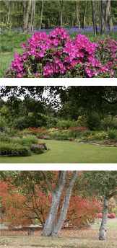
For 2027, entry costs £12.00. For groups of over 20 visitors, we offer a discounted rate of £10.00 per person.
(Please note: RHS memberships and Gardeners World 2 for 1 discounts do not apply when making a group booking)
What is the best time of year to visit?
- Green Island Gardens is the perfect garden to visit all year round. Open for 11 months of the year there are always new and exciting plants to see.
- February features snowdrops and hamamelis in the woodland with a wonderful display of scented flowering winter shrubs.
- March/April is bulbs time, plus a wide range of camellias and many unusual woodlanders such as Trillium
- May is a riot of colour with azaleas and Tulips, and carpets of Bluebells.
- June/July/August, the main beds start to fill with colour, peonies bloom, and the water gardens are spectacular
- October/November fill with colour, thanks to our highly acidic soil the wide range of Acers and other autumn colouring trees and shrubs setting the grounds ablaze

How much time would you recommend for a visit?
With 20 acres to see, you could spend an entire day at Green Island Gardens, but at minimum we would recommend between 3-4 hours. Many groups combine Green Island Gardens with other gardens in the area. If this is something that your group would like to do, we would recommend limiting the visits to one other garden, for the comfort of the groups.
Why do we need to pre-order food?
We request a pre-order for groups over 10 for a few reasons, mainly to ensure that we have sufficient supplies. As our food is based on fresh produce, we need to specially order in extra supplies to cater for a larger number, especially if there are specific dietary requirements. Secondly, our team is very small, often only 1 or 2 members of staff will care for the tearoom & food preparation. Without a pre-order, lunches would take a significantly longer time to prepare resulting in very long wait times for your group as well as our other customers. We understand that this requirement is additional work for the organiser but strongly believe that it positively enhances the whole garden visit experience for your group.
Do you have catering facilities?
Yes! Our tearoom can cater for 50+ people with our everyday menu offering homemade cakes and light lunches. For special occasions, we have cream teas and traditional afternoon teas, which can be pre-ordered at the time of booking.
Light lunches (toasties, soup, baguettes & jacket potatoes) start at £8.00
Cream tea (scones, jam, cream & tea/coffee) £8.50
Afternoon tea (sandwiches, scone, jam, cream, cake & tea/coffee) £19.00
For groups we offer a special £5.50 cake & tea/coffee, this discount is only available at the time of booking and must be for a minimum of 20 people or for the whole group if less than 20. We request that any catering required for your group be pre-ordered if group is over 10 visitors. If you cannot supply a pre-order or wish to allow your group to order at their own leisure, it is really helpful to still provide an indication of catering requirements.
How long is a guided tour?
The tour is led by Fiona or one of her knowledgeable staff and consists of a brief history of the house and gardens, followed by a walk around the main borders, water gardens, woodland gardens, seaside garden and finally the Japanese garden and terrace during which Fiona explains the development of the gardens over the last 20 years and points out many of her unusual plants. In total allow 1 1/2 hours with Q&A’s afterwards, cost £60.00
The tour is best suited to groups of up to 20 people, sometimes we can run more than one tour at a time to cater for groups over 20.
Are you disabled friendly?
Yes, we are. The grounds are mostly flat, with only one or two slight inclines and steps. For ease of entry into buildings we have temporary ramps, a dedicated disabled toilet and a wheelchair that is available for use.
Is there a shop?
Yes! The nursery has a wide variety of plants for sale, all of which can be seen in our gardens. Inside the tearoom there is a display of photographs and cards for sale.
Do you have parking facilities?
Yes. For regular vehicles entry is on Park Road, follow the signs down the drive, parking is the large lawn on the right opposite the tennis court. For coaches, entry is on the Bromley Road side of the property as this entry has a higher clearance, parking will be on the left opposite the tennis court. We can have a member of staff available to help guide your coach driver into the space for coaches if they require.
Can I take photos?
Photos can be taken at Green Island Garden, provided that the photographs are not for commercial purposes. We do ask that if any images are uploaded to the internet that you mention or tag Green Island Gardens- we love seeing photos from our visitors!
Can I bring my dog?
Unfortunately, dogs are not permitted at Green Island Gardens except for assistant dogs.
Can I bring a picnic?
You are welcome to bring a picnic with you; we have a dedicated picnic area by the car park with picnic tables that you are welcome to use. Food is not allowed to be consumed within the gardens. Please kindly take any rubbish home with you.

LIGHT LUNCHES MENU

Homemade soup - £8.00
Served with freshly baked bread roll and butter
Freshly cooked baguette - £8.50
Ham & Tomato
Ham & Cheese
Cheese & Pickle
Cheese & Tomato
Tuna Mayonnaise (£1.50 supplement)
Prawn & Marie Rose (£1.50 supplement)
Served with side salad
Toasted Sandwich - £8.00
Cheese
Cheese & Tomato
Ham & Cheese
Cheese & Pickle
Served with your choice of white or brown bread & side salad
Jacket Potato - £9.00
Tuna Mayonnaise (£1.50 supplement)
Cheese
Chilli Con Carne (£1.50 supplement)
Baked Beans
Extra filling (£1.00 supplement)
Served with side salad
Salad - £9.00
Ham
Cheese
Tuna Mayonnaise (£1.50 supplement)
Prawn & Marie Rose (£1.50 supplement)
Bread roll and butter £1.50
Ploughman’s platter, with cheese, ham, tasty chutney, salad and roll - £10.50
(This proves very popular with groups and can be served efficiently)

As all food is freshly prepared, we do request that groups over 20 pre-order lunches 1 week in advance. This allows us to ensure that we have sufficient supplies staff and can provide a speedier lunch service.

GREEN ISLAND GARDEN GROUP VISIT BOOKING FORM 2027

Group Name:
Group Contact:
Address:
Telephone:
Email Address:
Date: ____________________________________________________________________
Time of Arrival: _____________________ Expected Time of Departure: _____________________

Number of Visitors: Please select number of visitors and rate:
Group 20+ qty @ £10.00 = Or <20 qty @ £12.00 = ___________

Catering Requirements:
Pre-order is required for groups of 10+ with at least 1 week notice: number___________
(Required as we are a small team and want to provide the best service we can)

Tea & Cake qty @ £5.50 =___________
(Includes tea or coffee and any cake from the selection in the tearoom)
Cream Tea qty @ £8.50 =___________
(Includes 2 scones, jam, cream and endless refills of tea and coffee)
Afternoon Tea qty @ £19.00 =___________
(Includes fresh sandwiches, cream tea and homemade cakes, with endless refills of tea/coffee)
Ploughman’s Platter with cheese & ham qty@ £10.50 =___________

Guided tour required? @ £60.00 (20 persons max)
(Please bear in mind the walking ability of your group when booking a tour and notify us of any concerns)
Total costs for visit (Can be approx. if unsure)
Total cost for visit is to be paid in advance; we will not accept card payment either on the door or prior to the visit.
£20.00 non-refundable deposit please circle: Cheque (+£2.00 admin), Bank Transfer
How did you hear about Green Island Gardens?

Please tick to acknowledge
- Final numbers and requests to be phoned or emailed through a minimum of 3 days prior to visit.
- Visitors are asked to take care when visiting the gardens. Decking, stepping stones and tree house may be slippery. Please keep off the trampoline, climbing frame and swings. The owners cannot be held responsible for any accidents that may occur during the visit. Cars are parked at the owner’s risk.
- Coaches MUST enter the exit gate on Bromley Road as the entrance drive is too narrow.
- Please include our group into the Green Island Gardens mailing list
- Please tick if your group will be arriving by coach

Signature

Payment types accepted:
- Cheque - Payable to Green Island Gardens
(NB: £2.00 charge for payment by cheque)
- Bank Transfer - Sort: 20-22-67
Acc: 53792404
(Please use group name + date of visit as reference)
- Cash
Please return your booking form:
- Post: Green Island Gardens,
Park Road
Ardleigh, CO7 7SP
- Email: office.greenislandgardens@gmail.com

