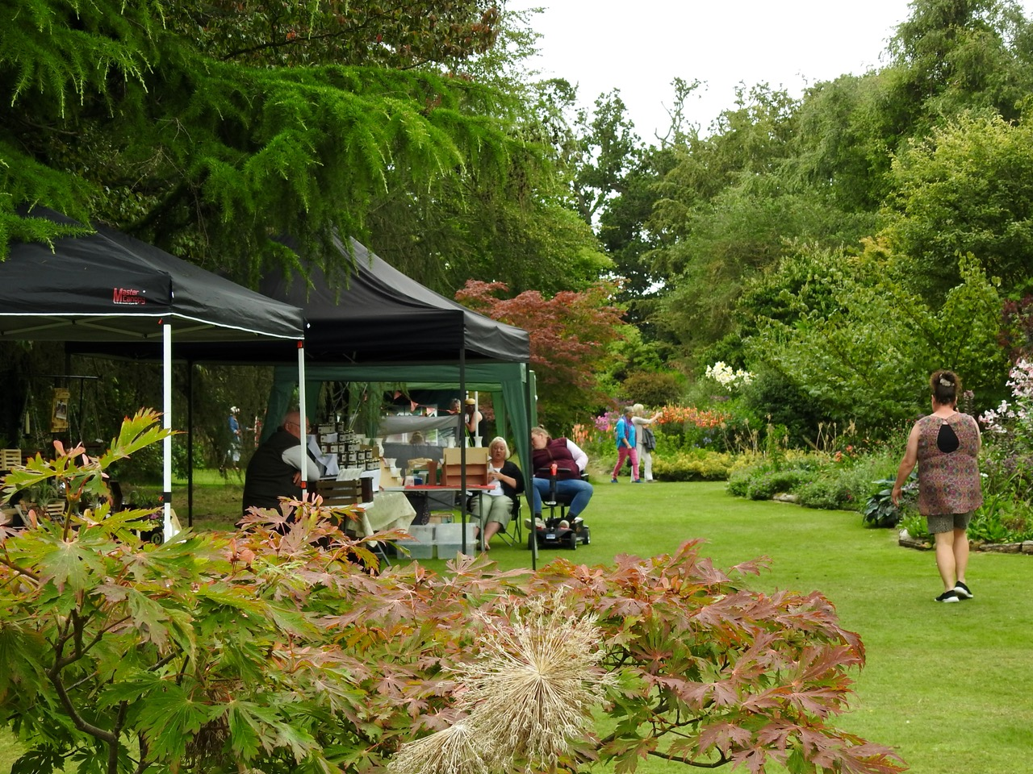

Green Island Gardens’ Bluebells Bazaar – 4th & 5th May 2024

Stall Holder Information

The Bazaar will be held on the 4th and 5th of May at Green Island Gardens, Park Road, Ardleigh, Colchester, Essex CO7 7SP. Stall holders are not required to attend both days; a discounted rate is available for those wishing to attend on one day only.

Individual sites are available at £40 for the weekend, or £25 for one day. For those who own gazebos/tents please bring them along as unfortunately we are unable to offer these. Each stall will receive 2 entry tickets, and further tickets for any extra staff can be purchased at the discounted rate of £5. Please see the Booking Form below.

Green Island Gardens will be promoting this weekend on our social media, website and posters throughout the district, but we do of course encourage you to promote this event as much as possible. We can supply promotional material for your social media pages on request.

Please include a copy of your public liability insurance when returning your booking form. Pitches will only be reserved upon receipt of payment and return of relevant forms.

We will do our best to accommodate specific individual needs wherever we can, just let us know. If you have any queries, pleased do not hesitate to contact Stephanie White at office.greenislandgardens@gmail.com or on 01206 230455

Refunds for cancellations will only be processed if at least one month’s notice is given, minus £10 admin fee. Alternatively, the fee can be transferred for pitch at our next garden event.

We look forward to having you with us for another wonderful weekend in the garden!
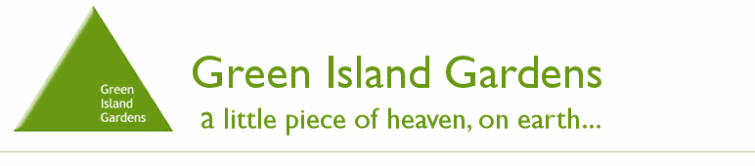
Bluebells Bazaar Booking Form
Saturday 4th & Sunday 5th May 2024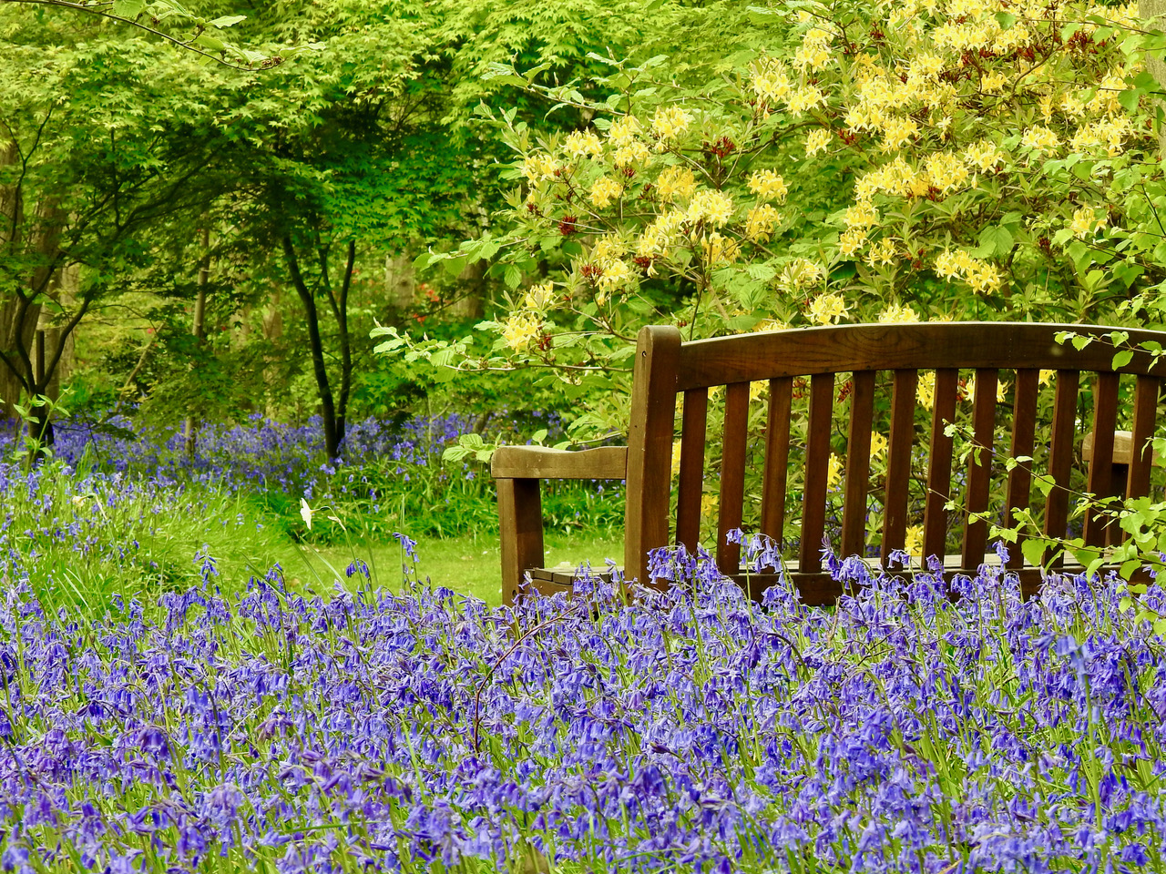
Company name_____________________________________________________________________
Point of contact__________________________________________________________________
Mobile number__________________________________________________________________
Email_____________________________________________________________________
Brief description of products__________________________________________________
Standard Pitch Size is 5 square metres. Do you require more space? _________________________________
Do you have any accessibility/other requirements? ________________________________
Saturday only/ Sunday only/ Weekend booking ___________________________________
Total to pay £25 (1 Day) or £40 (Weekend), Plus any Extra Entry Tickets (£5 each): _________________________________________________________________
Payment for pitch must be made at time of booking.
- Cheques, payable to ‘Green Island Gardens’ (there is a £1.50 charge for cheques)
- OR BACS, sort code: 20 22 67 Account number: 53792404. Please put reference as BB followed by the name of your stall.
- OR card payment over the phone: Tel 01206 230455.
Heavy or wide vehicles must enter Green Island via the exit gate, which is located on Bromley Road, on the opposite side of the garden to the entrance. We cannot accept liability for vehicles or products whilst on site. Please sign and return this form to confirm booking. Please note size of pitch is 5m x 5m.
Signature__________________________________________________________________

